# BUG REPORT

*Newly found Bugs will be updated*

## BUG 1

Title: Inconsistency in admin page while creating

Attachment:

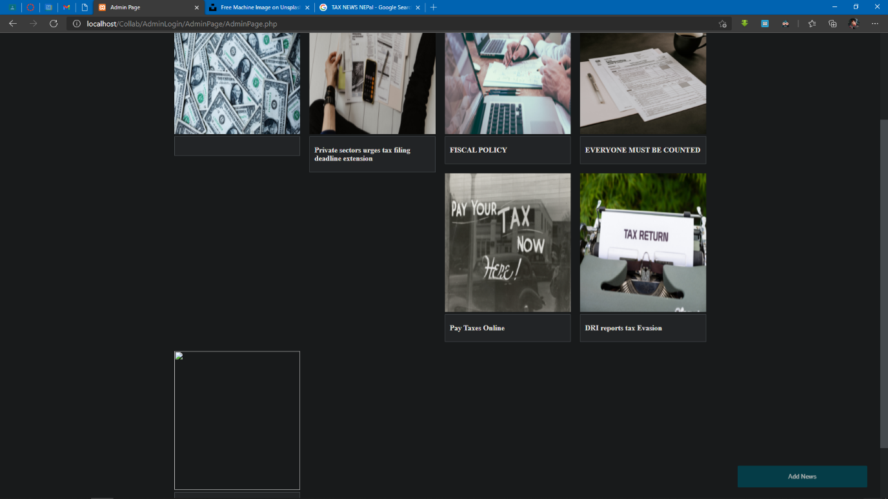

Steps to reproduce:

1. Add News
2. Fill the fields and add images
3. Repeat for multiple times till all the posts get un managed

Environment: Microsoft Edge Version 90.0.818.56

## BUG 2

Title: Obstruction during large images needs to be sized

Attachment:

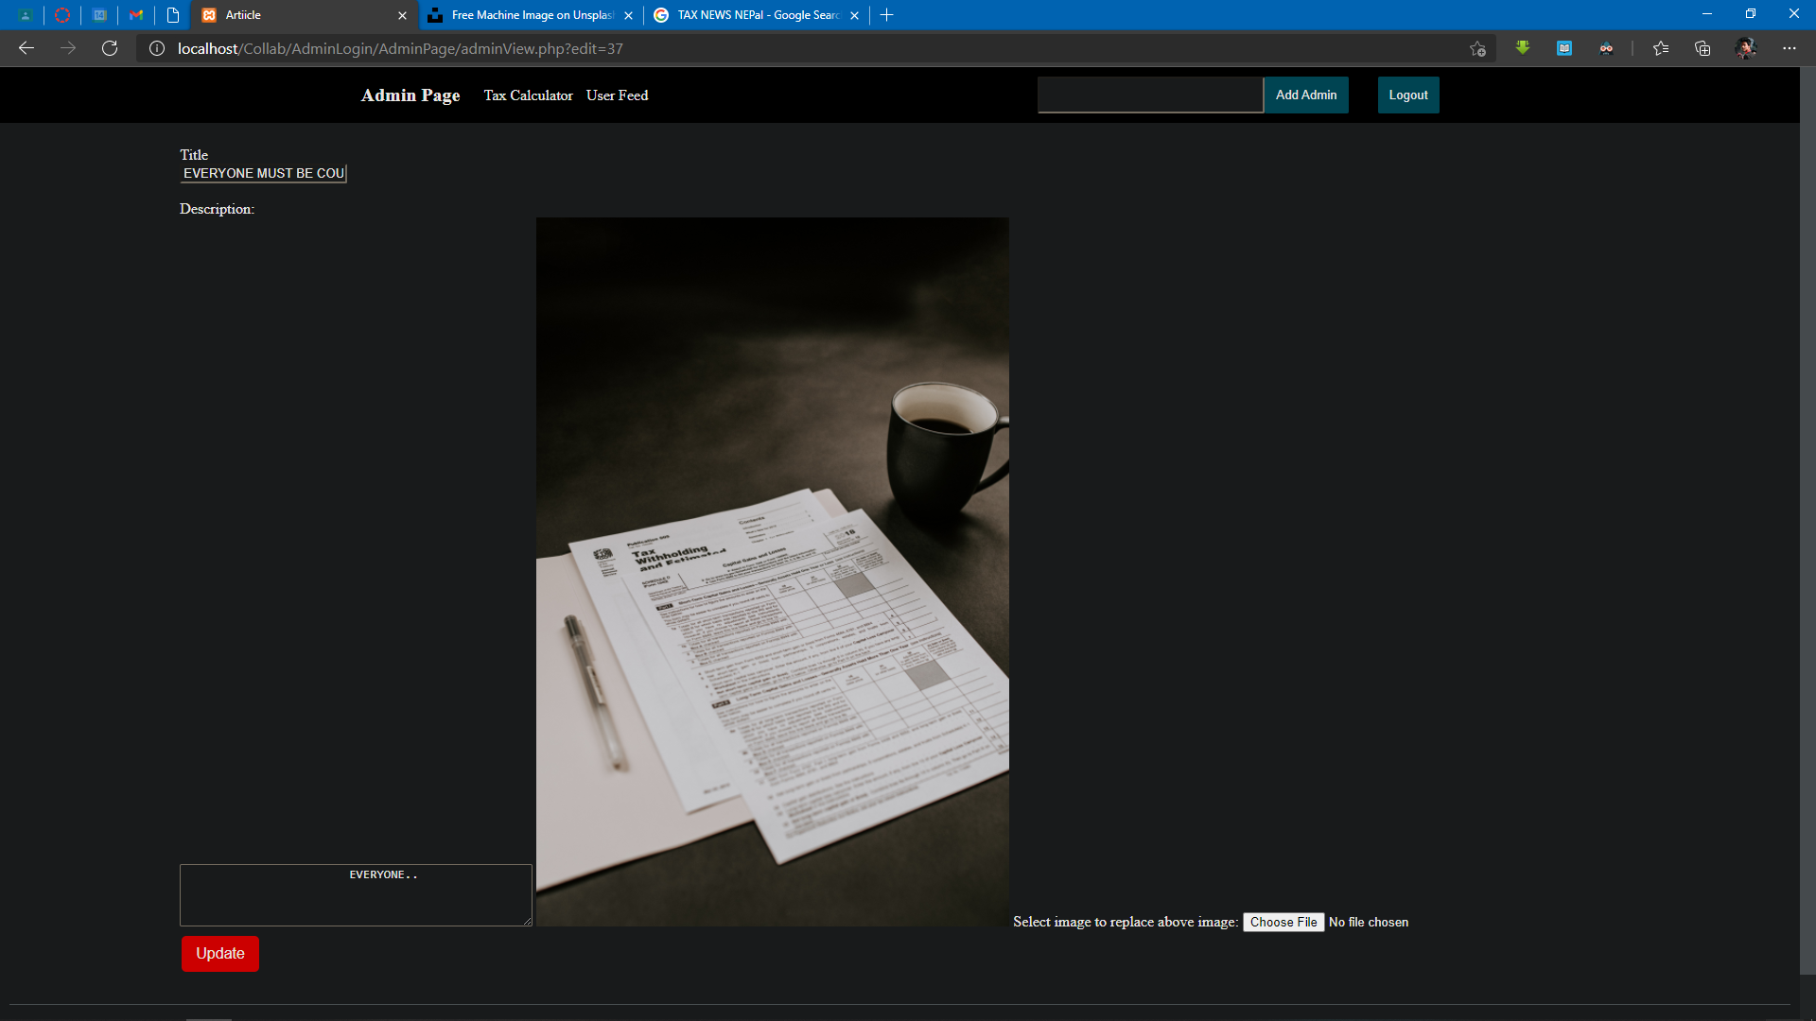

Steps to reproduce:

1. Click on edit news
2. Upload a large scaled image
3. The screen gets messy and obstructed

Environment: Microsoft Edge Version 90.0.818.56

## BUG 3

Title: Cancel button missing on the edit page

Attachment:



Steps to reproduce:

1. Hover on a post
2. Click on edit news
3. Cancel button does not exist and needs to be added

Environment: Microsoft Edge Version 90.0.818.56

## BUG 4

Title: Obstruction during large lines of titles needs to be sized

Attachment:

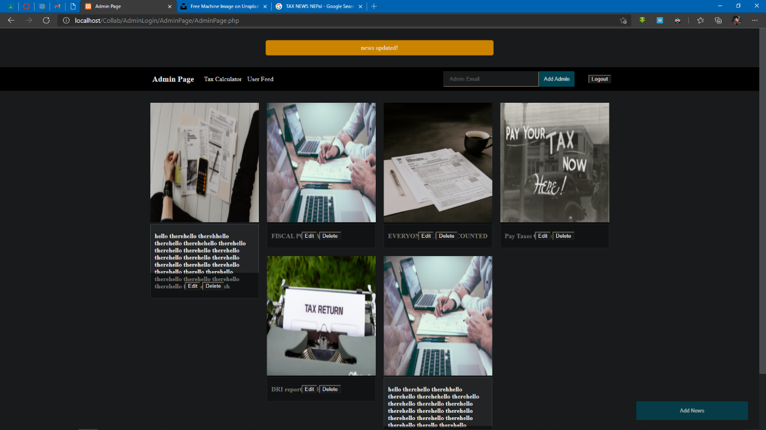

Steps to reproduce:

1. Create a new post
2. Enter huge lines of text in the title
3. Add description and image
4. Create the post and see the obstructed page

Environment: Microsoft Edge Version 90.0.818.56

## BUG 5

Title: Cannot remove the toast message

Attachment:

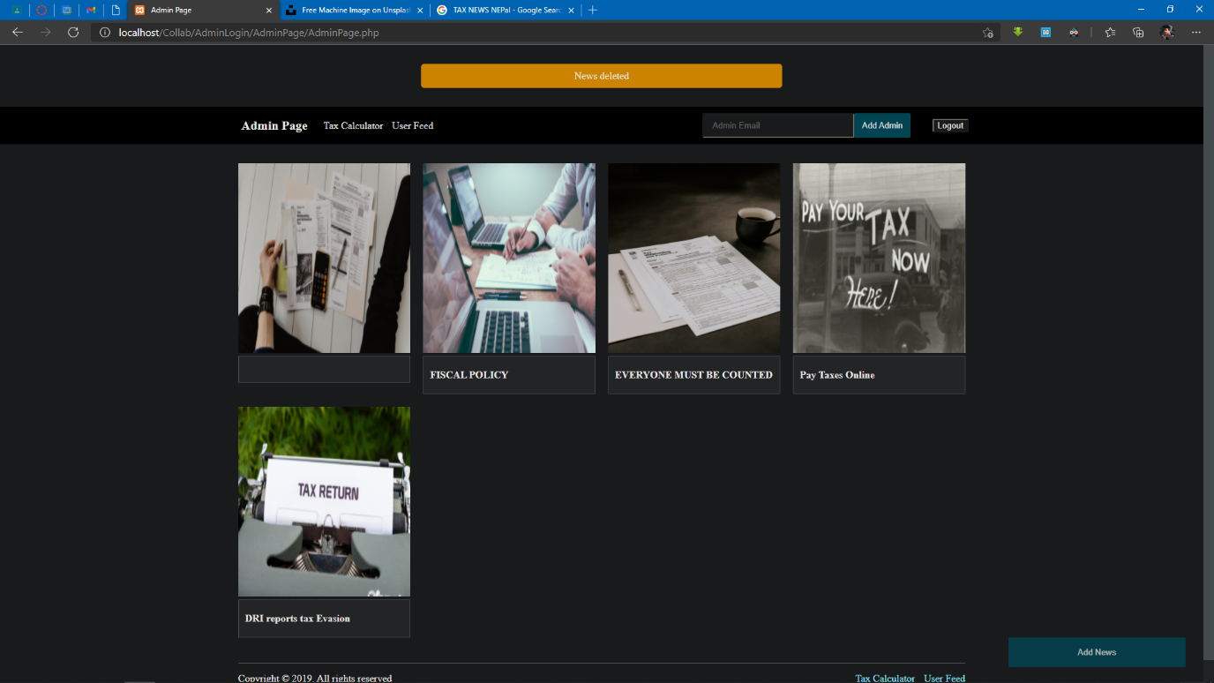

Steps to reproduce:

1. Hover over a post
2. Delete a post
3. A toast message appears that cannot be removed

Environment: Microsoft Edge Version 90.0.818.56